Analyze the tale of Kieu of the Great Poet Nguyen Du by using IT and AI tech

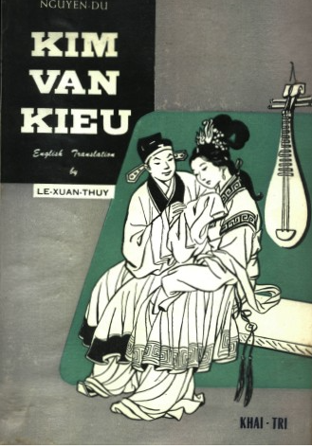

Cited: <https://lau.marketing/ve-ai/>

"How did the author of 'The Tale of Kieu' teach me to paint with AI (artificial intelligence)?"

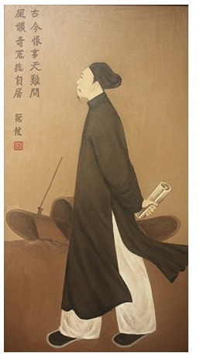

The great poet Nguyen Du, the author of 'The Tale of Kieu,' is the one who guided me on how to command AI. When I say this, almost everyone is skeptical. And everyone wants to know, how did the strange encounter between an 18th-century poet and 21st-century AI technology really take place?

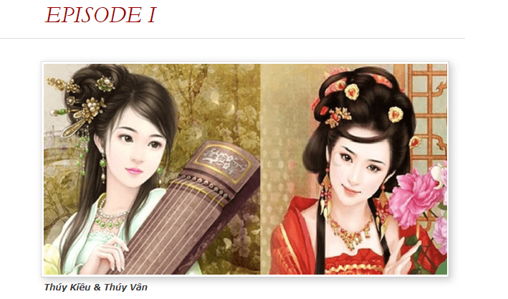

**Cited:** [**https://truyenkieuinenglish.wordpress.com/episode-v/**](https://truyenkieuinenglish.wordpress.com/episode-v/)

Prompt:

*two East Asian sister, both with apricot bodies and snow spirit, unique style and perfect beauty, younger sister with full moon face, eyebrows two long arcs, smile like a flower, voice sounds of jade, older sister more attractive and charming, surpass her sister in talent and beauty, realistic.*

*Cited* [*Tri Vo*](https://www.linkedin.com/pulse/nguy%E1%BB%85n-du-%C4%91%C3%A3-d%E1%BA%A1y-t%C3%B4i-v%E1%BA%BD-truy%E1%BB%87n-ki%E1%BB%81u-v%E1%BB%9Bi-ai-nh%C6%B0-th%E1%BA%BF-n%C3%A0o-tri-vo/)

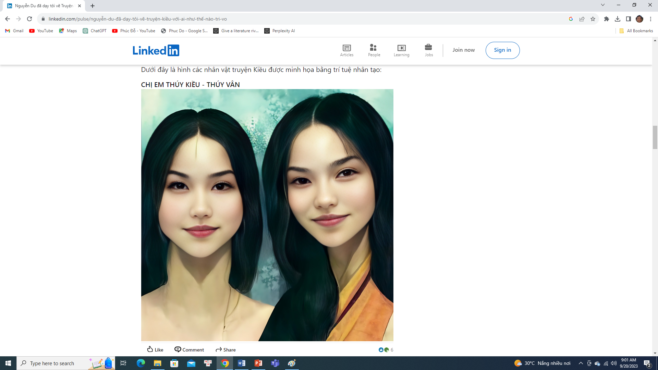

Prompt: an East Asian man lived in Ming Dynasty, was described as a tall or big man with lion’s beard, swallow’s jaw and silkworm’s brows, owned large shoulders and massive body, a brave general who was fond of a struggling life style of adventure, unmatched in martial art and skill of warfare.

Cited: <https://lau.marketing/ve-ai/>

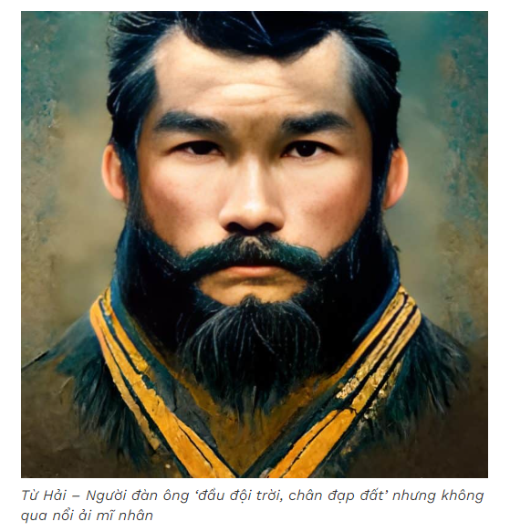

# [*THE ENGLISH VERSION OF TRUYỆN KIỀU*](https://truyenkieuinenglish.wordpress.com/) *(2020)*

## *~ By Phan Huy MPH*

## Organize a text DB to save Tale of Kieu in Vietnamese and English

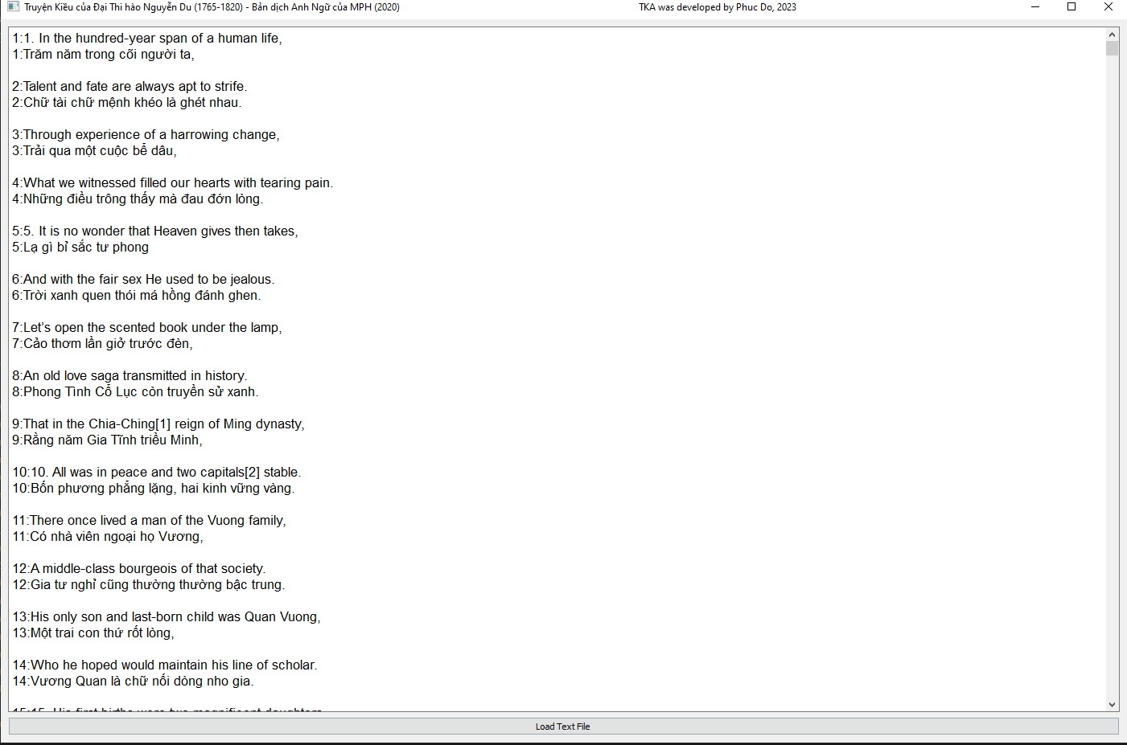

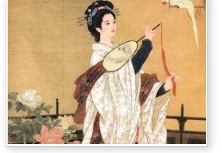

**Cited:** [**https://truyenkieuinenglish.wordpress.com/episode-v/**](https://truyenkieuinenglish.wordpress.com/episode-v/)

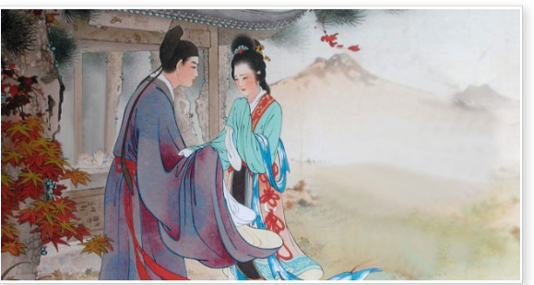

**Cited:** [**https://truyenkieuinenglish.wordpress.com/episode-v/**](https://truyenkieuinenglish.wordpress.com/episode-v/)

**Use AI to explain the meaning of each sentence of the tale of Kieu (2022)**



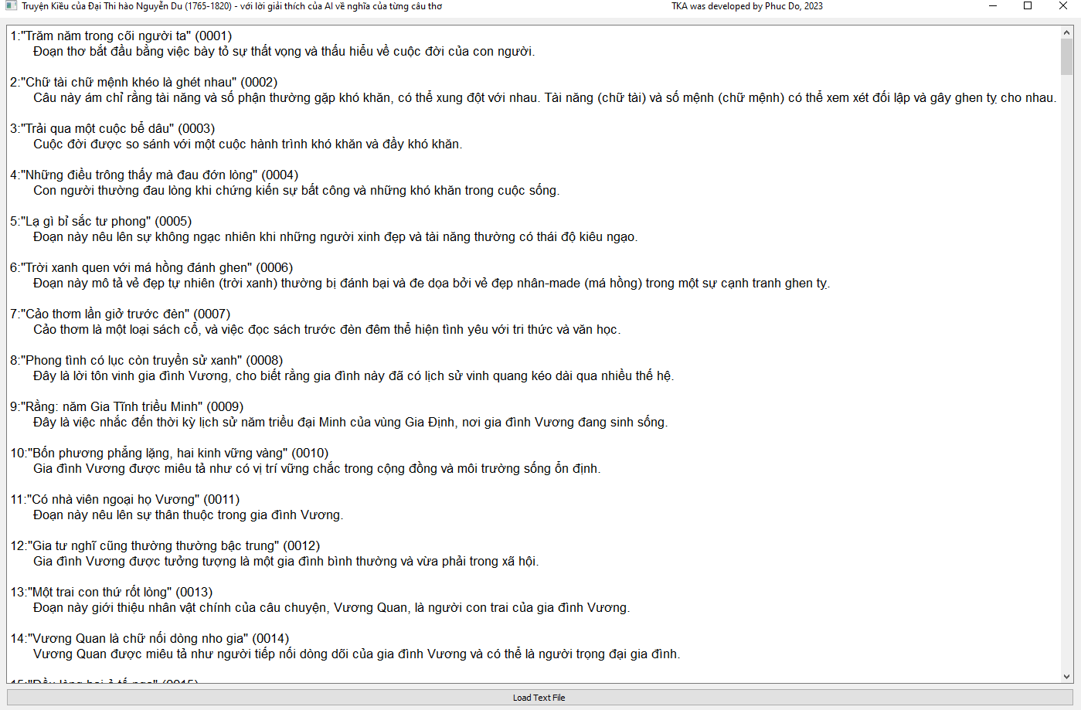

**Trích dẫn truyện Kiều (2022)**

Quoted excerpt from "Truyện Kiều" by Nguyễn Du

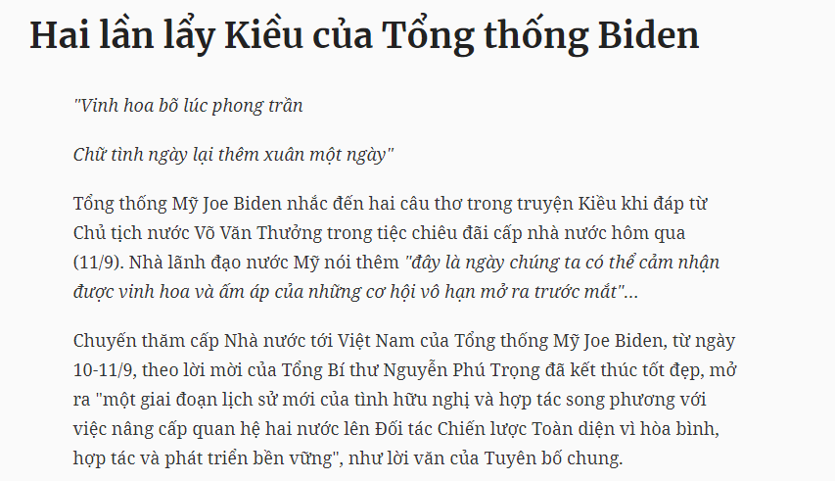

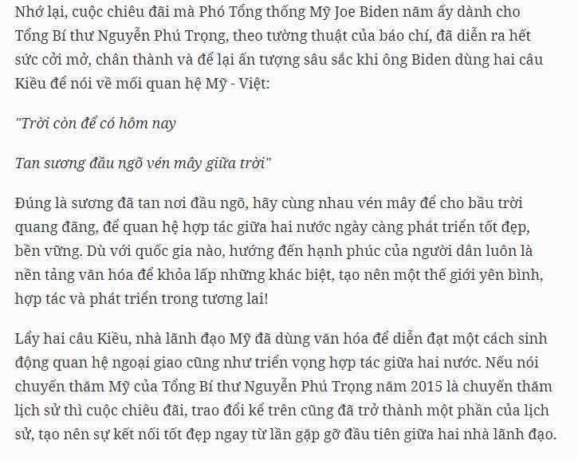

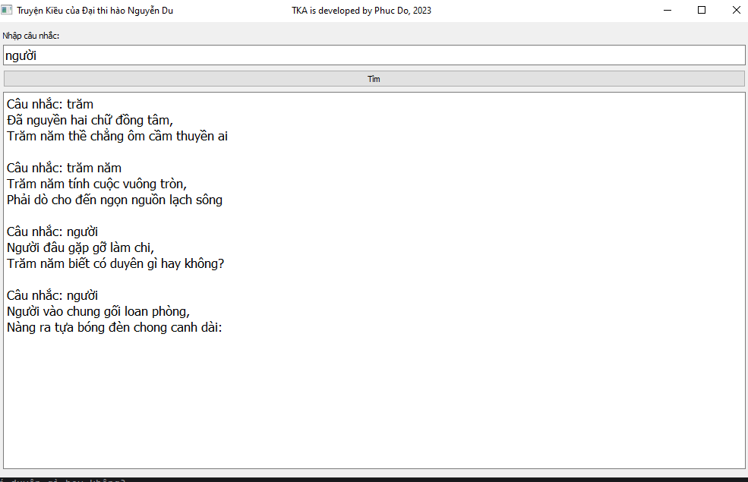

**Phân tích cảm xúc và phân loại theo nội dung từng câu**

**Sentiment analysis and topic classification (2020)**

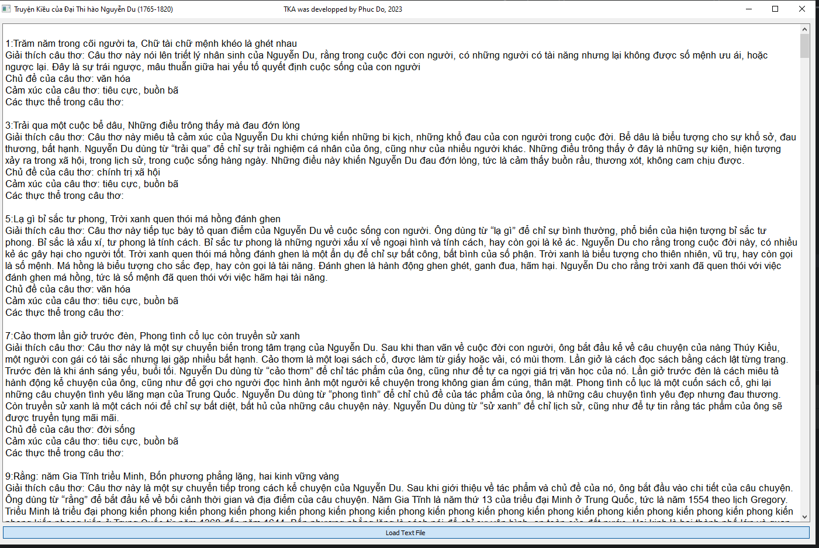

**Occurrence Visualization Analysis (2017)**

**Tale of Kieu, Great Poet Nguyen Du**

**Visualize the occurrence of word in the tale of Kieu (2017)**

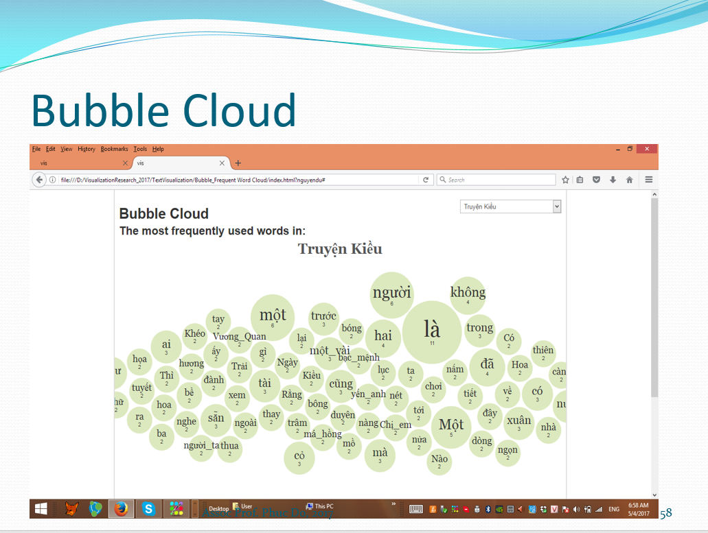

**Co-occurrence word graph (2017)**

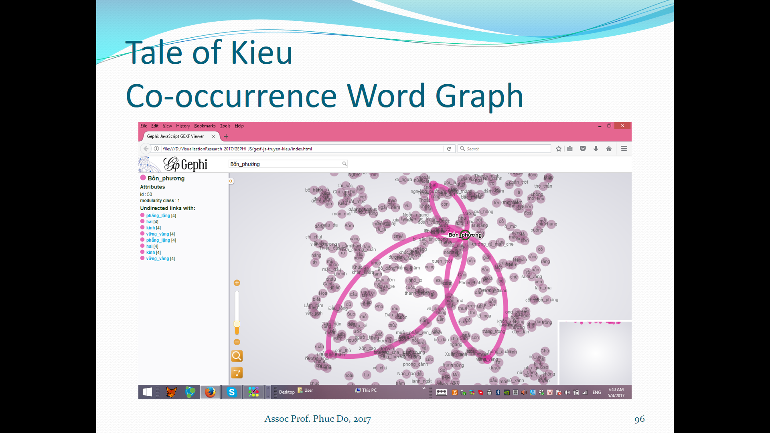

**SimiIarity sentence graph (2017)**

